SUPPLEMENTARY REGULATIONS

BMU European Motocross Championship 2026 (together with Türkiye National Championship)

Round : 5

Date : 22-23.08.2026

Venue : Hayrabolu Burak Ozel MX Track

City : Tekirdağ
Country : Türkiye

ORGANIZERS

FMN : TMF – Türkiye Motorcycling Federation

Club : BAMOS – Baskent Motorcycle Sports Club

CLASSES
MX50, MX65, MX85, MX1, MX2, MX125, MX, MX SENIOR, MXWOMEN

ACCESS
See attached map

Nearest city: Afyon, 9km from the circuit
GPS coordinates of the circuit: 38.790154, 30.482880 (https://goo.gl/maps/kQwRj79K231c2Pek8)

- CIRCUIT INFORMATION
Name : Hayrabolu Burak Ozel MX Track
Length : 1.650 mt
Width : 8 mt
Homologation: TMF Homologation 2026

NEAREST HOSPITAL
Name: Hayrabolu Devlet Hastanesi
Approximate distance from venue: 5 km
- OFFICIALS
BMU Steward: | TBA
Race Director: | Zeynur ÖZTÜRK
Chief Technical Steward: | Tamer KAYA
Administrative control : | Sultan UYAR
Paddock Official: | Ali ULUSAN
Timekeeper: | TMF Timing
CMO: | TBA

MEETINGS OF THE RACE DIRECTION
Friday : 18:00
Saturday : 09:15
Sunday : 17:00
Venue: Race Direction Office

ADMINISTRATIVE ANDTECHNICAL CONTROL
Friday 15:00 –18:00 / Saturday 07:30 – 09:00

INSURANCE, ENTRIES AND STARTING PERMISSIONS
All riders must be authorised by their national federation (FMN) in order to participate in the event(s) via starting permission plus license confirmation (to be presented at the administrative control).
All entries must be sent a minimum of 2 days before the beginning of the administrative control. All riders will be required to sign additional documents at the administrative control.
Riders under the age of 18 (minors) must be accompanied by a legal representative (parent or guardian) at the technical and administrative control.

By signing and stamping the Starting permission for a rider, their FMN declares that the rider in question:
- has a valid insurance for motorcycling sports according to FIM Europe requirements,
- has no bans or prohibitions that prevent them to participate in the event,
- is physically and mentally fit to participate in the event,
- has the sporting skills of the required level in order to participate in the event without endangering him or other participants during the event

The organisers disclaim all responsibility for damage to a motorcycle, its accessories and components arising out of an accident, fire or other cases.
The organisers have contracted a third-party insurance according the BMU regulations for the days of the event (Friday, Saturday and Sunday) for the amount of 20.000 Euro.

All Starting Permissions must be sent to the organizers of the race and to
Ertan PEHLIVAN Email: info@tmf.org.tr

ENTRY FEE
60 euro per rider for all classes: MX1, MX2, MX125 2T , MX, MX SENIOR, WOMEN
40 euro per rider for classes: MX65, MX85, MX50.
Entry Fee should be paid Cash in EUR or TRY currencies.

FREE PRACTICES, TIME PRACTICES AND RACES
Free practices, Qualifying Practices and Races will be run according to the timetable enclosed.

RENUNCIATION OF ANY RECOURSE AGAINST SPORTING AUTHORITIES

Riders renounce all rights of appeal against the organizer, his representatives or agents by arbitration or before a tribunal or any other manner not foreseen by the BMU Regulations or the FIM Europe Sporting Code where applicable, for any damages for which they could be liable in consequence of all acts or omissions on the part of the organizer, his officials, representatives or agents in the application of these regulations or contributed to or arising out of their actions.

SPECIFIC AND ADDITIONAL REGULATIONS FOR THE EVENT:

- Riders and their service vehicles will be positioned in the paddock area by the organiser’s responsible.
- The starting permission for the event of riders MX50 must include the date of birth of the rider.
- Starting Permissions should be sent by the FMN of the Rider. Riders with starting permissions on paper will not be accepted.
- Customs Information for Foreign Competitors(Visitors) for your information.

Do not Forget Documents to prepare before arrival are:
- Passport
- Visa (if required)
- ATA Carnet (recommended)
- Packing list for equipment
- Underage racers must be accompanied by their legal guardians
- Starting Permission
- Sporting Licence
For an invitation letter;
FMN of the racer sends an email to info@tmf.org.tr, with the racer's information below
Name SURNAME , Date of Birth, Nationality, Duty for invitation letter.

For visa requirements;
Visit https://www.mfa.gov.tr/visa-information-for-foreigners.en.mfa/default.en.mfa

Note: The VISA regime for truck drivers of a country may differ from the overall visa regime effective for citizens of that particular country. For further information, please contact the nearest Turkish mission.

ATA Carnet for temporary admission:
ATA Carnet applications can be made through the Chamber of Commerce in your country/location.

For more information, visit:
ICC World Chambers Federation – ATA Carnet System

Note:
Prepare your ATA Carnet in an Excel file on a USB Memory.
So your application can be done more easily at customs.
At customs, your ATA Carnet procedures should be applied by a customs agency

Place and date: ANKARA 24.07.2026

Approved by Organisers National Federation: TMF
Approved by Race Director: Zeynur ÖZTÜRK
Approved by BMU:

HAYRABOLU MX TRACK
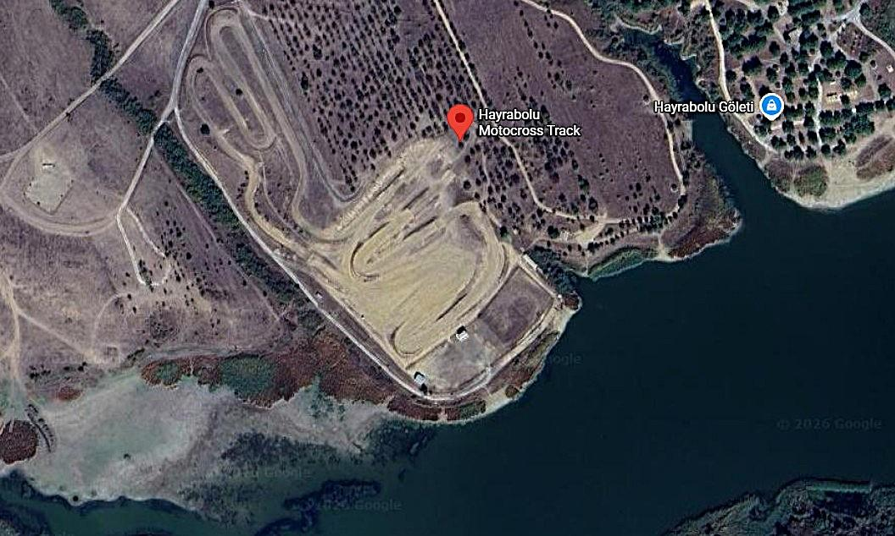

HAYRABOLU MX TRACK